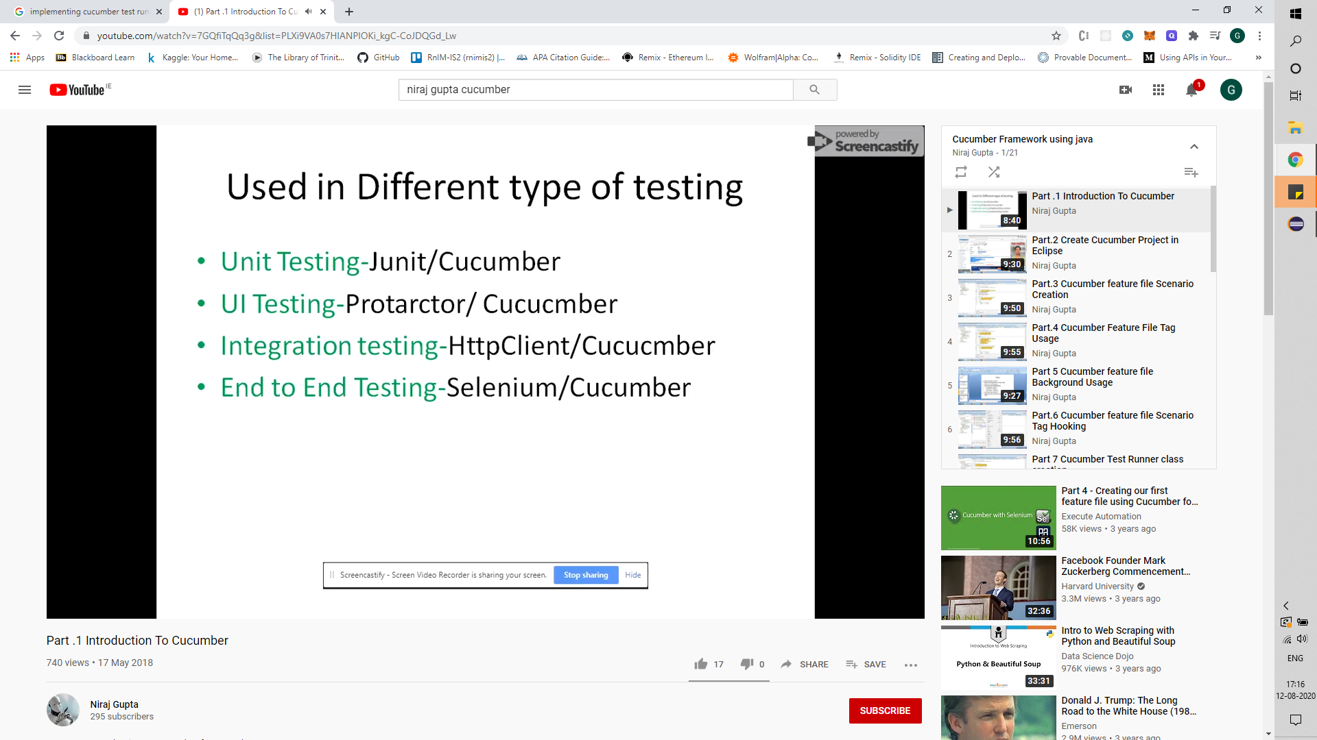

**Learning Cucumber:**

Cucumber is an open-source software testing tool that supports BDD. Gherkin is a business readable, domain specific language that Cucumber uses for behaviour descriptions.

**Maven Dependencies**

Java-cucumber, cucumber-junit, junit

**Feature File**

Keywords – Feature, Scenario, Scenario Outline, Given, When, Then, And, But, Examples – which contains a table to execute the steps specified with different parameters.

Annotations - @<tag name>

**StepDefinition Class**

Contains implementations for the Given, When and Then defined in the scenario files

Tags - @Before(used to execute statements before the scenarios are executed)

**TestRunner Class**

Tags –

@RunWith (parameters – Cucumber.class),

@CucumberOptions(parameters – features(features files or folders to be considered), tags(annotated tags to be executed in the feature files), plugin(for reports) and glue(package name to searched for))

**Background**

Background keyword is used in a feature file to execute a set of given, when and Then before running each scenario. It is a set common to all scenarios, to avoid redundancy.

E.g.,

Feature: <Feature name>

Background:

Given <English statement>

When < English statement>

Then < English statement>

**Tables/Map/List**

A scenario can have a table(columns and rows), map(key-value pairs)

E.g.,

|username| password|

|George |pass1 |

|paul |pass2 |

**Hooking**

This is done using annotations - @Before() and @After(). Used to initialize drivers/http client for web services testing/DB connection and close those browsers/drivers/DB connection/clients/take screenshots.

Three types –

before() / after() without argument;

before() / after() with tag argument e.g., @Before(“@tag1”) - executes only for @tag1 | @Before(“~@tag2”) – executes all except @tag2;

before() / after() with order argument e.g., @Before(order = 1);

**Explanation**

**Examples** – which contains a table to execute the steps specified with different parameters. Parameters specified as “<param 1>” which is a column name.

**Scenario** – parameters specified as “param 1”

Tags – These are annotations used by cucumber to run features and scenarios. They are of different types: Feature level, scenario level, example level(mapped to scenario level tags) and

**StepDefinition Class**

* The step definition class contains the actions to be performed for each of the Given, When, Then and But annotations specified in the Feature file.
* The shortcut to generating methods is to execute the Feature file without defining and mapping those methods.

**Reports**

Reports for the execution is generated using plugin keyword within the @CucumberOptions()

E.g., @CucumberOptions(features=”path”, tags = “@tag1”, plugin = {“pretty”, “html:<path/filename.html”, “json:path”, “junit:path”})

Learn ScenarioOutline, Examples, Tables – List<type>, List<List<type>>, Map<k,v>